# Chapter 1: Introduction

## Abstract

The circular economy system is an innovative and sustainable platform designed to facilitate the transition from a linear "take-make-dispose" model to a circular model that promotes resource efficiency, waste reduction, and value creation. This system aims to create a closed-loop economy where products and materials are reused, remanufactured, and recycled, minimizing environmental impact and maximizing economic and social benefits.

The system provides an online marketplace where users can buy and sell a wide range of products, encouraging the exchange of pre-owned goods and promoting the concept of sharing and reuse. It offers a user-friendly interface that allows individuals and businesses to list their products, set prices, and connect with potential buyers. Users can easily search for products based on various criteria and make secure transactions through integrated payment gateways.

To ensure the smooth functioning of the system, robust features are implemented, including inventory management, order tracking, and secure payment processing. Users can track the lifecycle of their products, from listing to sale, and participate in the circular economy by extending the lifespan of goods and reducing waste.

The system also emphasizes community engagement and awareness by providing educational resources, tips for sustainable living, and a forum for users to exchange ideas and experiences. It promotes collaboration among individuals, businesses, and organizations, fostering a culture of sustainability and responsible consumption.

By implementing the circular economy system, businesses can unlock new revenue streams, reduce resource dependence, and enhance their environmental credentials. Individuals can contribute to a more sustainable future by embracing circular practices and making informed purchasing decisions.

## Problem Statement

In today's linear economy, resources are extracted, used, and disposed of, leading to significant environmental degradation and resource depletion. There is a growing need to transition towards a circular economy, where resources are kept in use for as long as possible, and waste is minimized. However, individuals and businesses often face challenges in finding and accessing sustainable products, recycling options, and opportunities to participate in the circular economy.

The problem is that there is a lack of a centralized platform that connects individuals, businesses, and organizations involved in the circular economy. This platform would enable users to easily find, buy, sell, and exchange sustainable products, materials, and services. It would also provide information on recycling, upcycling, and other circular practices, fostering a community that promotes sustainable living and supports the circular economy principles.

The circular economy website aims to address this problem by creating an online platform that connects users with sustainable products, facilitates resource sharing and recycling, and promotes awareness and engagement in circular practices. The website will serve as a one-stop destination for individuals and businesses looking to participate in the circular economy, fostering a more sustainable and environmentally conscious society.

## Objectives

### Research Objectives

1. Assess the current state of the circular economy and identify key challenges and opportunities.
2. Understand the needs and preferences of target users in relation to circular economy practices and solutions.
3. Explore best practices and case studies of successful circular economy initiatives.
4. Analyze the environmental, social, and economic benefits of adopting circular economy principles.

### System Development Objectives

1. Develop a user-friendly and intuitive website interface that promotes engagement and information dissemination.
2. Implement a robust search and filtering system to allow users to easily find relevant information, products, or services related to the circular economy.
3. Create a secure and scalable database system to manage user profiles, product listings, and transactions.

### Project Objectives (research methods, topics)

## Project Justification

## Project Scope

1. User Registration and Authentication:

* Allow users to create accounts and authenticate themselves.
* Implement secure user authentication mechanisms, such as password hashing and session management.

1. Product Listings:

* Provide a platform for users to list and browse products.
* Implement search and filtering options for users to find relevant products.
* Include features like product images, descriptions, categories, and pricing information.

1. Cart and Checkout:

* Enable users to add products to their cart and proceed to checkout.
* Calculate the total price of the items in the cart.
* Implement a secure and user-friendly checkout process, including payment options and shipping address entry.

1. Order Management:

* Allow users to view their order history and track the status of their orders.
* Provide notifications or emails to keep users updated on their order progress.

1. Payment Integration:

* Integrate with payment gateways or APIs to facilitate secure payment transactions.
* Support multiple payment methods, such as card payments and mobile money transfers.

1. User Profiles and Dashboard:

* Provide user profiles where users can manage their personal information.

# Chapter 2: Literature Review

## Introduction

## Feasibility Study

### Technical Feasibility

### Operational Feasibility

### Schedule Feasibility

# Chapter 3: System Analysis and Design

## System Development Methodology

### Spiral Model

## System Analysis

## Requirements Specification

### Functional requirements

1. **User Registration:**

Allow users to create an account and provide necessary information.

1. **Product Listing:**

Display a list of available products with their details.

1. **Shopping Cart:**

Enable users to add products to their cart, update quantities, and remove items.

1. **Payment Processing:**

Provide options for users to make payments securely using M-Pesa or card.

1. **Order Management:**

Allow users to view and track their orders, view order history, and receive order confirmation.

### Non-functional requirements

1. **Performance:**

The website should load quickly and handle multiple concurrent users without significant performance degradation.

1. **Usability:**

The website should have an intuitive and user-friendly interface, allowing users to easily navigate, search for products, and complete transactions.

1. **Security:**

The website should implement robust security measures to protect user data, prevent unauthorized access, and ensure secure payment processing.

1. **Reliability:**

The website should be highly available, with minimal downtime and the ability to recover from failures.

1. **Scalability:**

The system should be scalable to accommodate future growth in terms of user traffic, product catalog, and transactions.

### Pseudo-requirements

### System Design

### System Architecture Design

### Database Design

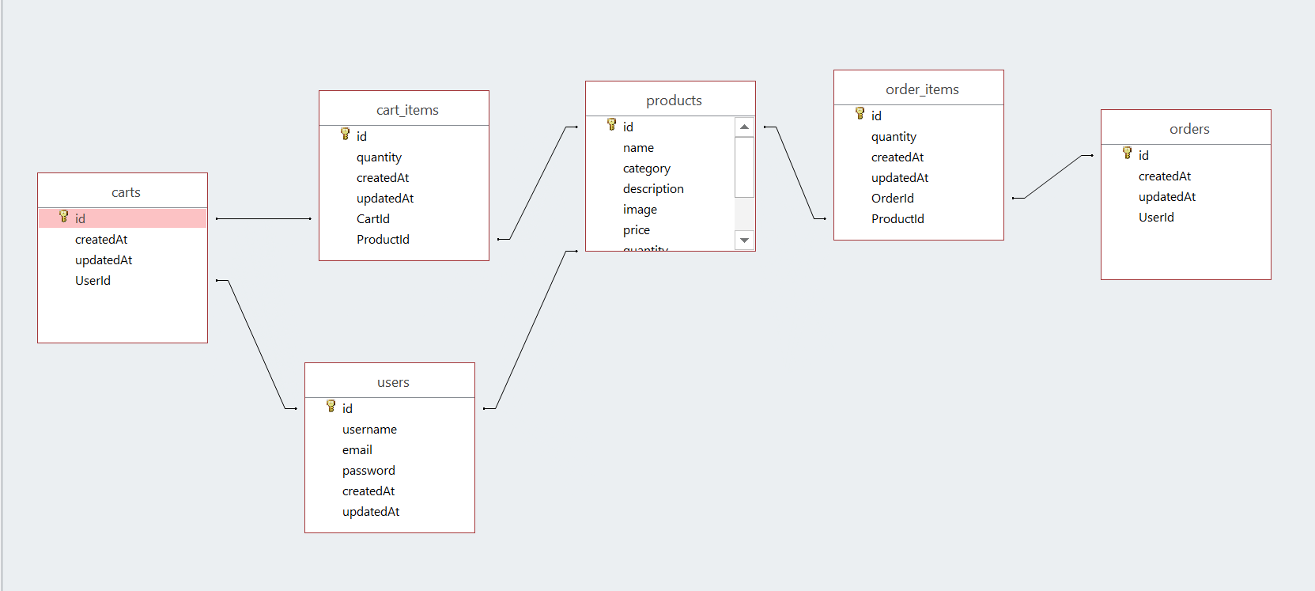

### UI Design

### **Login and Registration Pages**

### Login View

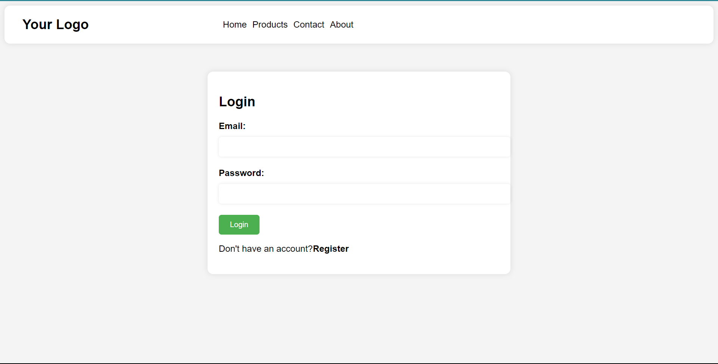

### Registration View

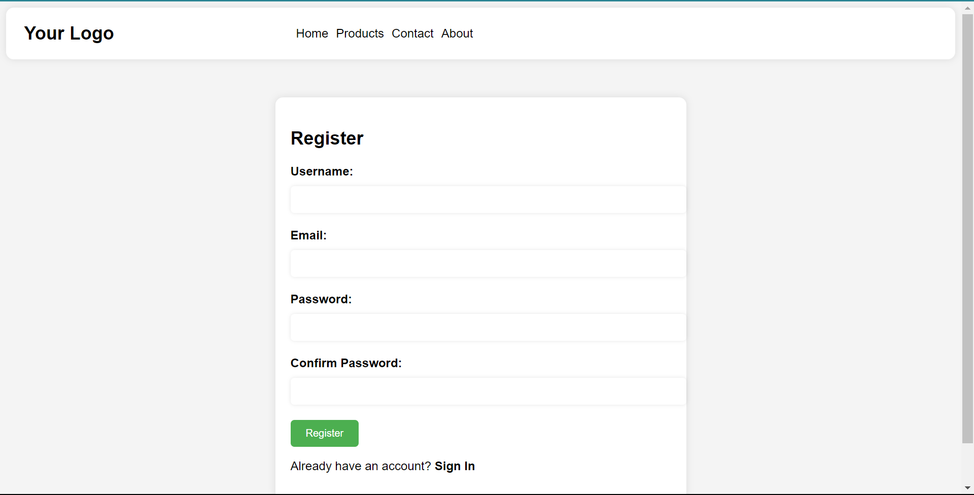

### **Content Pages**

### Home View

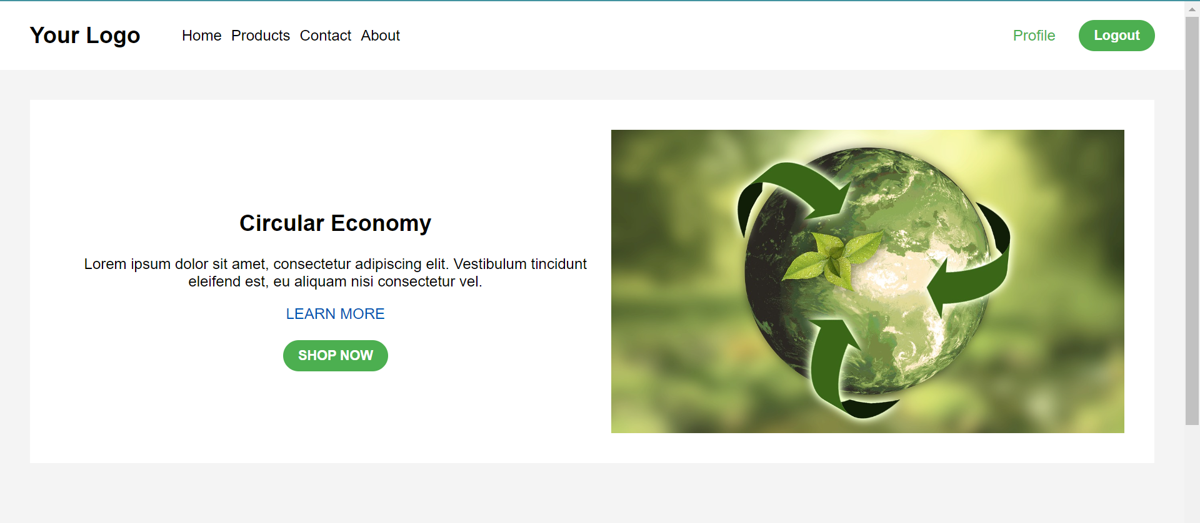

### Products View

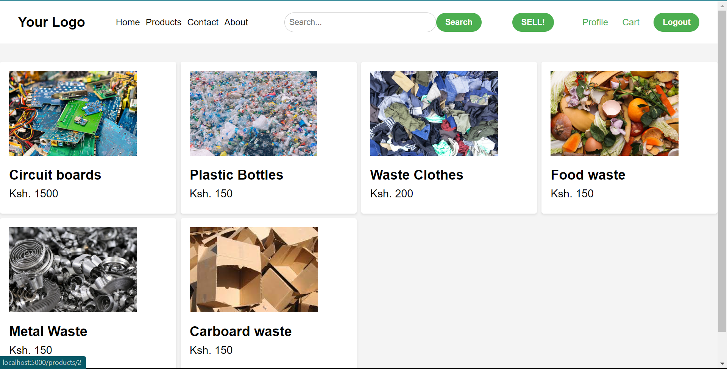

### Single-Product View

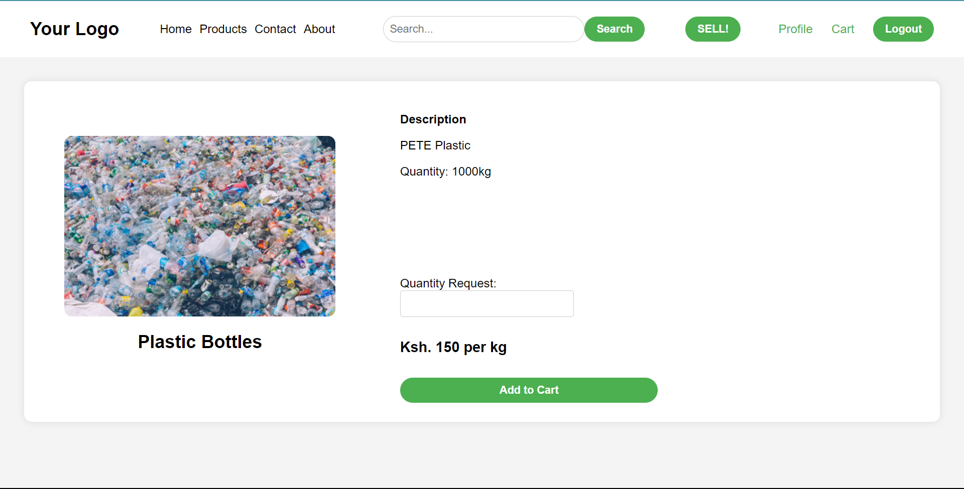

### Profile View

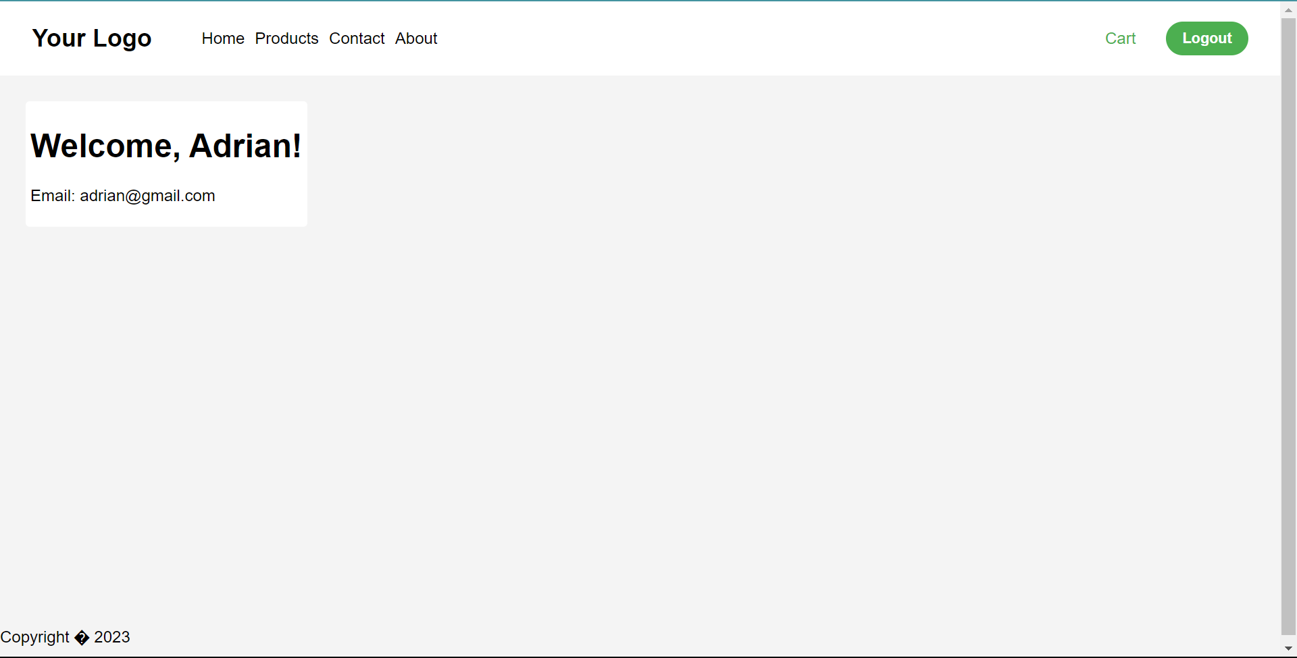

### Cart View

